**Task#1**

Create a website that at minimum satisfies the following requirements: • It should include different HTML elements e.g. headings, paragraph(s), lists, images, text hyperlinks, image hyperlinks, bookmarks, image maps, tables, text formatting, forms, etc. • It should include appropriate and rich content such as short biography, education and training courses, projects that you have a major role in it, summer training, skills, and useful web links, contacts, etc. • Be consistent in all styles and make it user-friendly with an appealing layout. • You can use any style of CSS like Inline CSS, External CSS, or Inpage CSS

**Html Code:**

<!DOCTYPE html>

<html>

<head>

    <link rel="stylesheet" href="task1.css">

<title>Page Title</title>

<style>

    a:link {

      color: green;

      background-color: transparent;

      text-decoration: none;

    }

    a:visited {

      color: pink;

      background-color: transparent;

      text-decoration: none;

    }

    a:hover {

      color: red;

      background-color: transparent;

      text-decoration: underline;

    }

    a:active {

      color: yellow;

      background-color: transparent;

      text-decoration: underline;

    }

    </style>

</head>

<body>

    <img src="face.png" alt="face" width="100" height="100">

    <p><a href="#C4">Jump to Skills</a></p>

    <p><a href="#C10">Jump to Experience</a></p>

<h1>This is a Resume</h1>

<div id="header"></div>

<div class="left"></div>

<div class="stuff">

  <br><br>

  <h1>Resume</h1>

  <h2>Fahad Malik</h2>

  <hr />

  <br>

  <p class="head">Interests</p>

  <ul>

    <li>Drawing</li>

    <li>Photography</li>

    <li>Design</li>

    <li>Programming</li>

    <li>Computer Science</li>

    <h2>Skills</h2>

    <p>This section explains Skills</p>

  </ul>

  <p class="head">Skills</p>

  <ul>

    <li>Web Design with HTML & CSS</li>

  </ul>

  <p class="head">Education</p>

  <ul>

    <a href="http://www.wiltonhighschool.org/pages/Wilton_High_School">

      <li>Wilton High School</li>

    </a>

    <!--Link-->

    <a href="https://www.silvermineart.org/">

      <li>Silvermine School of Arts</li>

    </a>

    <li>Codeacademy</li>

  </ul>

  <h2>Experience</h2>

    <p>This section explains Experiences</p>

  <p class="head">Experience</p>

  <ul>

    <li>Receptionist at City hospital</li>

    <li>Pizza Delivery Services at PizzaMax </li>

  </ul>

  <p class="head">Extracurriculars</p>

  <ul>

    <li>Recycling Club</li>

    <li>Gardening Club</li>

    <li>Book Club</li>

  </ul>

</div>

<div class="right"></div>

<div id="footer">

  <h2 id="name">Fahad Malik</h2></div>

</body></html>

**CSS Code:**

* {

    max-width: 700px;

    margin: auto;

  }

  /*body {

      min-width: 500px;

  }*/

  div {

    border-radius: 5px;

  }

  #header {

    height: 40px;

    width: 100%;

    background-color: #ffcccc;

    position: fixed;

    z-index: 1;

  }

  #title {

    margin-left: 3%;

  }

  #footer {

    height: 50px;

    width: 100%;

    background-color: #ffcccc;

    clear: both;

    position: relative;

  }

  .left {

    height: 1000px;

    width: 45px;

    background-color: #e0eeee;

    float: left;

    position: fixed;

  }

  .right {

    height: 1000px;

    width: 45px;

    background-color: #e0eeee;

    float: right;

    position: inherit;

  }

  .stuff {

    display: inline-block;

    margin-top: 6px;

    margin-left: 55px;

    width: 75%;

    height: 1000px;

  }

  p,

  li {

    font-family: 'Cormorant Garamond';

  }

  .head {

    font-size: 20px;

  }

  #name {

    font-family: Sacramento;

    float: right;

    margin-top: 10px;

    margin-right: 4%;

  }

  a {

    color: rgb(0, 0, 0);

    text-decoration: none;

  }

  @media only screen and (max-width: 430px) {

    .left,

    .right {

      display: none;

    }

    .stuff {

      width: 100%;

      margin-left: 10px;

    }

  }

**Output:**

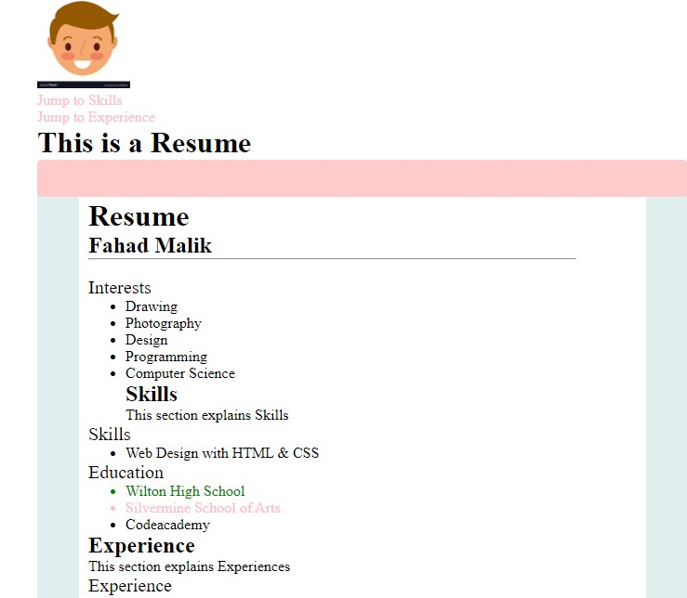

Task#2:

Use HTML and CSS to create your own personal resume, using the following example as a template.The text in the page title should be rendered in small caps. • The page title and the text of section headers should be dark blue. • The resume should have a title running across the top (with dark blue bars above and below). • The content area should be to the left and the sidebar (contact info) should be to the right. • Use div and span elements with id and class attributes to specify the body of the HTML document. • All visual styling should be done separately in CSS rules

**Html Code:**

<!DOCTYPE html>

<html>

<head>

    <link rel="stylesheet" href="task2.css">

<title>Page Title</title>

<style>

h3{

  border: 1px solid rgb(5, 23, 100);

  margin-top: 60px;

  margin-bottom: 40px;

  margin-right: 40px;

  margin-left:480px;

  text-decoration-color: rgb(16, 4, 80);

}

h1 {

  text-decoration-line: overline underline;

  text-decoration-color: rgb(28, 9, 134);

}

    </style>

</head>

<body>

    <h1>Fahad Malik ------- RESUME</h1>

<h3 style="color:rgb(7, 13, 99);"><u> Contact Information: </u>

 House #328, block# 10, F.B Area, Karachi, Sindh , Cell number: 033434343456,

 email: csarim35978@gmail.com

</h3>

<div id="header"></div>

<div class="left"></div>

<div class="stuff">

  <br>

    <p ><u>Objective</u></p>

    <li> To develop web app for fun and profit</li>

  <p class="head"><u>Education</u></p>

      <li>BS in COmputer Science, 2020, SSUET,block # 05, Gulshan, KHI.    </li>

  <p class="head"><u>Experience</u></p>

  <ul>

    <li>Receptionist at City hospital</li>

    <li>Pizza Delivery Services at PizzaMax </li>

  </ul>

  <p class="head"><u>Skills</u></p>

  <li>Java, Java servelts, Html, CSS, UML </li>

  <p class="head"><u>Refrences</u></p>

    <li>Available upon Request</li>

  <hr></hr>

</body>

</html>

**CSS Code**

 h1 {

    text-align: center;

  }

  h3 {

    text-align: right;

  }

**Output:**

